Final Project - Brand & Wireframe Sketch Sheet

1. Brand Colors
Hex Code | RGB Value
#244A73 | RGB 36, 74, 115
#4A90D9 | RGB 74, 144, 217
#F2F2F2 | RGB 242, 242, 242
#F4C27A | RGB 244, 194, 122
#9EDEC3 | RGB 158, 222, 195
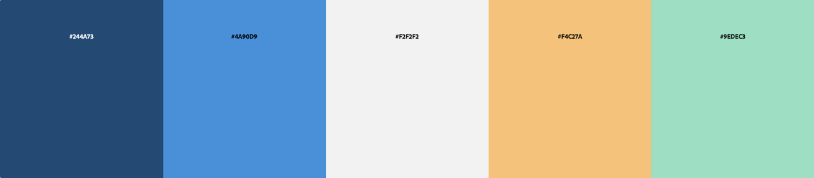

2. Brand Notes
Write your initial visual ideas:
- Possible fonts that match the brand
- Tone/voice of the company (serious, playful, engaging, sarcastic, etc.)
- How /where will use the provided colors
  - Background Coffee and croissant
  - Font
  - Accents #9edec3 (cyan), #9eacde (lavender), #dea99e (peach), #25342e (text color),
  - Etc..

3. Required Pages
List your four planned pages and what will go on each: like index.html (Home), products.html, etc.
- Homepage: Intro
  - Content: A basic outline of what this business is and what it’s for.
- Page Two: Menu
  - Content:
- Page Three: Events
  - Content:
- Page Four:
  - Content:

4. Wireframe Sketches
Examples: https://tinyurl.com/wireframe-ex
Hand‑draw a rough wireframe for both mobile and desktop layouts. Show placement of:
- Logo
- Navigation
- Headings
- Main content areas
- Images
- Footer
Mobile View Wireframe (draw in the space below):

Desktop View Wireframe – Multi-column (draw in the space below):

